H.T No
Regulations:
A18

Sreenidhi Institute of Science and Technology
(An Autonomous Institution)
Code No: 7AC07 Date: 08-Oct-2021 (FN)

B.Tech III-Year I- Semester External Examination, Sept/Oct - 2021 (Supplementary)
CONTROL SYSTEMS (ECE)

Time: 3 Hours Max.Marks:70

Note: a) No additional answer sheets will be provided.
b) All sub-parts of a question must be answered at one place only, otherwise it will not be valued.
c) Missing data can be assumed suitably.

ANSWER ANY 5 OUT OF 8 QUESTIONS. EACH QUESTION CARRIES 14 MARKS.

Bloom's Cognitive Levels of Learning (BCLL)

Remember | L1 | Apply | L3 | Evaluate | L5
Understand | L2 | Analyze | L4 | Create | L6

 |  |  | BCLL | CO(s) | Marks
1. | a) | Determine the transfer function X₁(s)/F(s) for the mechanical system shown in figure.  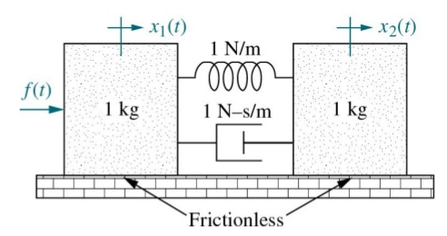 | L3 | CO1 | [7M]
 | b) | Determine the transfer function of the system represented by below signal flow graph.  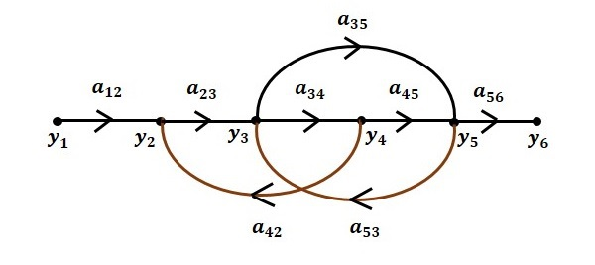 | L3 | CO1 | [7M]
2. | a) | Derive the expressions for time response specifications of underdamped control system when a unit step input is applied. | L3 | CO2 | [7M]
 | b) | Determine the position, velocity and acceleration error constants for the following unity feedback systems having forward path transfer function  . | L3 | CO2 | [7M]
3. | a) | Test for stability and determine the location of roots of the characteristic equation | L3 | CO3 | [7M]
 | b) | Sketch root locus for the system having transfer function  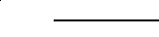  Also comment on the stability. | L3 | CO3 | [7M]
4. | a) | Define bandwidth. Derive expression for bandwidth of second order system. | L2 | CO4 | [7M]
 | b) | Sketch the bode plot for following transfer function and determine the gain margin and phase margin of the system. Also comment on the stability of the system.  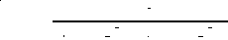 | L3 | CO4 | [7M]
5. | a) | Sketch polar plot for the unity feedback system with open loop transfer function  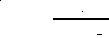 | L3 | CO5 | [7M]
 | b) | State and explain the Nyquist stability criterion | L2 | CO5 | [7M]
6. | a) | Define state transition matrix and List its Properties. | L2 | CO6 | [7M]
 | b) | Derive the transfer function corresponding to the following state model. | L3 | CO6 | [7M]
7. | a) | Explain working principle of Synchros. | L2 | CO1 | [5M]
 | b) | Explain the effect of proportional, derivative & integral controllers. | L2 | CO2 | [5M]
 | c) | Explain the concept of Routh stability, considering all the possible cases. | L2 | CO3 | [4M]
8. | a) | Explain the procedure to determine phase margin and gain margin from Bode plot. | L2 | CO4 | [5M]
 | b) | Explain step by step design procedure of Lead-Lag compensator. | L2 | CO5 | [5M]
 | c) | The state equations of linear time variant system are represented by  Find the state transition matrix for | L3 | CO6 | [4M]

-- 00 -- 00 –

